[Date]

Frank Schulz

WEB701

NMIT

Project Documentation

Nelson Food Tavern Website

Contents

Milestone One 2

Site Goals 3

Mission or purpose 3

Short- and long-term goals 3

Intended Audience 3

Why will people come to the web site 3

Define the User Experience 4

Define the Audience 4

Create Scenarios 4

Competitive Analysis 4

Site Content 9

Identify Content and Functional Requirements 9

Group and Label Content 9

Site Structure 10

Metaphor Exploration 10

Site Structure listing 10

Architectural Blueprints 11

Define navigation 11

Visual Design 12

Layout grids 12

Design Sketches and Page Mock ups 17

Revisions 22

Group and Label Content 22

**Notes:**

DevOps Board:

https://dev.azure.com/Frank-Schulz/WEB701-Project/_workitems/recentlyupdated/

# Milestone One

## Site Goals

### Mission or purpose

The members of the Nelson Food Tavern (henceforth NFT) are interested in having a website of their own. Read the following brief description on the proposed website:

|  |
| --- |
| The NFT Charity are a food bank charity in the Nelson region who accept food donations from the local community and distribute it to people in need.  NFT need a website for the Nelson region for members of the charity to provide food to our beneficiaries more effectively.    The purpose of the new website is to help with the distribution of the service or product by members of our charity to customers. Like a “food bank”, the website lets members register and describe the service or products they are providing, the number and frequency of the offerings.    The website lets members of the community (beneficiaries) access the service, by providing tokens that can be “spent” in the service. To achieve our goal, we would like to have an online token function on our website that let a beneficiary access a limited number of tokens, for example the system needs a mechanism that verifies that a member of the community is accessing the service and that the token belongs to a particular community member. The website needs some homepage text about general information of our products and services such as: types, characteristics, quality factor, usage and benefit. |

### Short- and long-term goals

#### Short-term

To get the site operational and spread knowledge of its existence.

Set up the necessary procedures to provide their new service.

#### Long-term

For the NTF website to be an effective bridge between members and beneficiaries.

### Intended Audience

The site is aimed at improving and growing the interaction and reach of NFT’s existing service, which is to provide a platform for Nelson residents who are either (or both):

1. Members, who wish to donate food they have available or
2. Beneficiaries, who are in need of food donations due to hardship.

Nelson businesses can also be members.

### Why will people come to the web site

1. In order to list food on the website for other people to order.
2. In order to browse for orders for food so that they can eat without needing to spend what little money they have or going hungry.

## Define the User Experience

### Define the Audience

There are two types of users that would use the NFT website which have been defined in an earlier section (Intended Audience).

### Create Scenarios

**People wishing to donate food.**

James is a Nelson local who has realised that he currently has more food stocked than he needs. Rather than letting it go to waste he decides to go to the NFT website and lists the items he wishes to put up for donation. Now someone who is in need of food can order the items that James listed and not go hungry.

A Nelson business that currently has surplus food would rather the food not go to waste. So they list it on the NFT website so that it can benefit those in need.

**People wishing to collect donated food.**

Michael has been a beneficiary of NFT’s service for a little while, with the website he can now order food from the comfort of his home and pick it up later, rather than having to go to NFT in person and hoping for the best. This way Michael can save time and money.

### Competitive Analysis

Other sites that belong to food bank style charities:

<https://www.foodbank.co.nz/nelson-community-foodbank>

<https://www.nelsoncommunityfoodbank.org.nz/>

<https://wck.org/>

#### Action Against Hunger:

#### Nelson Community Food Bank:

#### World Central Kitchen:

## Site Content

### Identify Content and Functional Requirements

#### Functional requirements

1. Charity members and beneficiaries can register, log in and administer their own accounts.
2. Members use the website to register their products and services, and beneficiaries use the system to acquire tokens.
3. Interactive element(s) that engages the website user.
4. The system provides an interface that the members can use to accept a token in a transaction.
5. Charity members and beneficiaries can register, log in and administer their own accounts.
6. Members use the website to register their products and services, and beneficiaries use the system to acquire tokens.
7. Interactive element(s) that engages the website user.
8. The system provides an interface that the members can use to accept a token in a transaction. (Token validation)
9. Homepage contains general information of NFT’s products and services such as: types, characteristics, quality factor, usage, and benefit.

Token/voucher system:

Users get a set number of vouchers per month (3) up to a certain amount. (8)

A voucher is equal in value to 3 products.

Tokens are used as a “receipt” to validate an order on pick-up.

### Group and Label Content

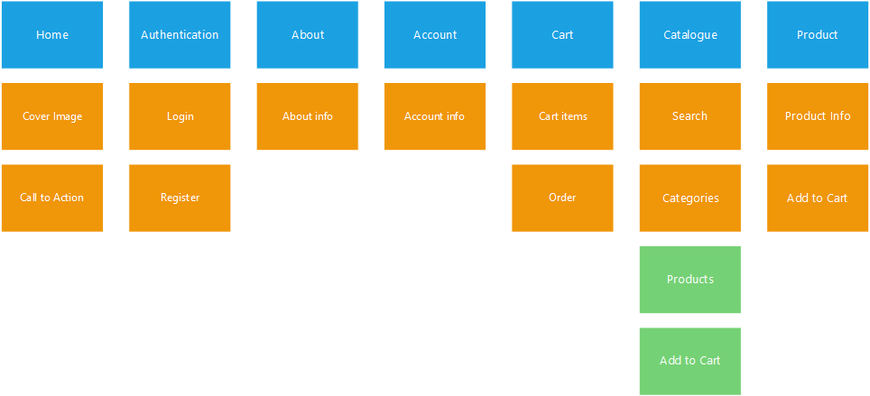

## Site Structure

### Metaphor Exploration

#### Organisational metaphors

NFT is an open and friendly place, and the site should reflect that. As such the site should not be crowded and will be setup as intuitively as sensibly possible.

#### Functional metaphors

There are no functional metaphors prominent enough to be built into the site, except for perhaps, that the site is unintrusive and orderly.

#### Visual metaphors

As NFT is a food charity, the site should be bright and inviting. Colours could be inspired by food e.g. vegetables, fruit, etc.

White will likely be the predominant background colour, promoting a positive and clean feeling.

### Site Structure listing

(Navbar layout)

* Navbar
  + Home
  + About
  + Catalogue
  + (If signed in) Tokens
  + Sign in / Account

(Footer layout)

* Footer
  + About
  + Contact info

(Site layout)

* Home
  + Navbar
  + Cover Image
  + Welcome and explanation
  + Call to action
  + Footer
* About Us
  + Navbar
  + Introduce NFT
  + Footer
* Catalogue
  + Navbar
  + Categories
    - Products
* Product
  + Navbar
  + Product Description
  + Add to Order
  + Footer

### Architectural Blueprints

### Define navigation

#### Global navigation

The global navigation (which will sit at the top of the page) will allow users to move between the following pages:

1. Home
2. About
3. Catalogue
4. Login / Account

#### Local navigation

The only local navigation that will be used is when clicking on a product in the catalogue to see its product page.

## Visual Design

### Layout grids

#### Home

#### About

#### Catalogue

#### Product

#### Account

#### Login

#### Register

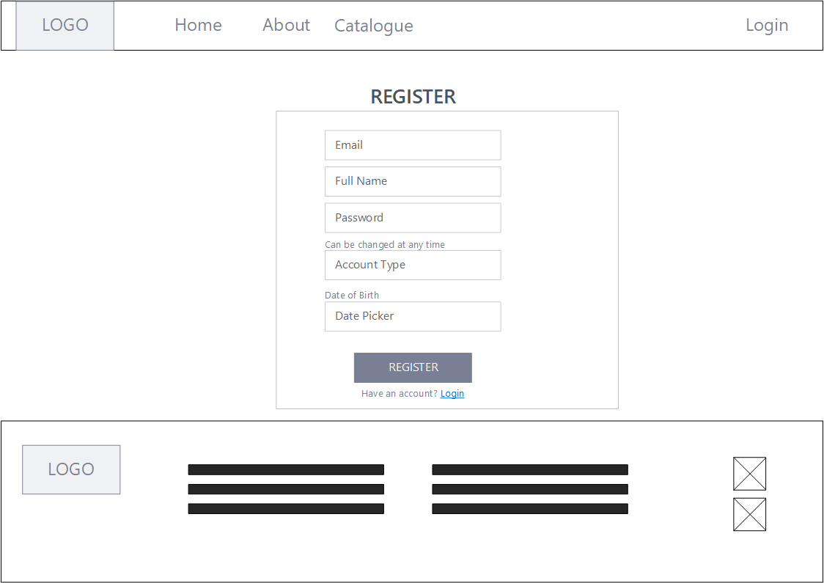

### Design Sketches and Page Mock ups

#### Home

#### About

#### Catalogue

#### Product

#### Account

#### Login

#### Register

## CRUD Table

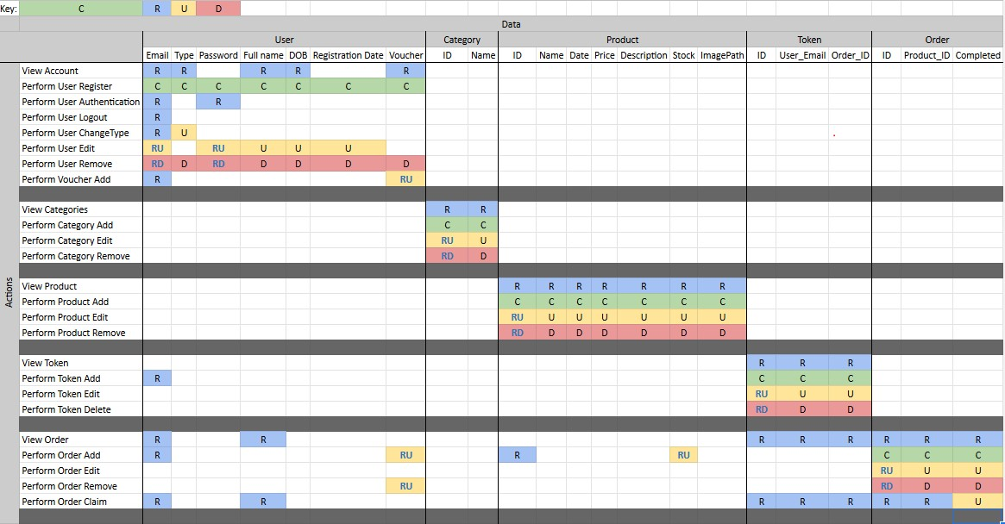

## Revisions

After further deliberation during the design process it was decided that the cart functionality was not required. As such the following elements have had their design revised.

Note: some things did not need to be revised as the had not yet been designed at the time of this decision.

### Group and Label Content

Cart was removed.

